Typical historical houses of the different ethnographic regions of Lithuania

Lithuania can be divided into historical and cultural regions (called ethnographic regions). The exact borders are not fully clear, as the regions are not official political or administrative units. They are delimited by culture, such as country traditions, traditional lifestyle, songs, tales, architecture etc. Due to the natural conditions Lithuanian folk architecture is entirely made of wood.
- Aukštaitija (Literally Highlands). Region in northeastern Lithuania. Traditional houses in Aukštaitija were double- ended. They were narrow and long. Windows were decorated with transom. The door was solid, beautiful and decorated with sashes. The roof was made of straw.
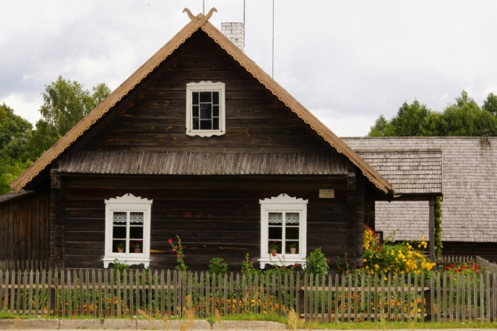
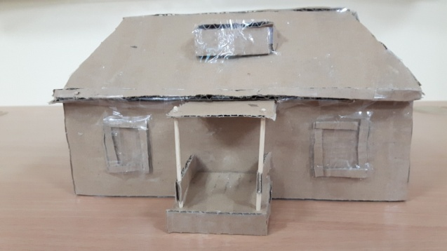

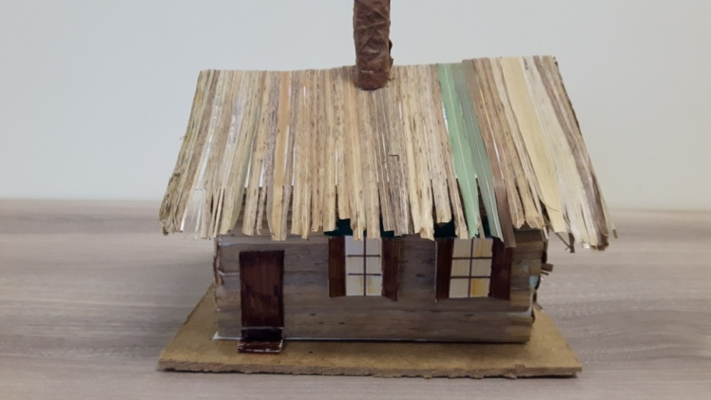

- Samogitia, (Žemaitija, literally Lowlands). Region in western Lithuania. Traditional Samogitian houses were massive, wide and mostly double-ended. Windows were decorated with shutters. The straw roof had four slopes.
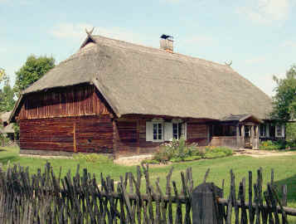
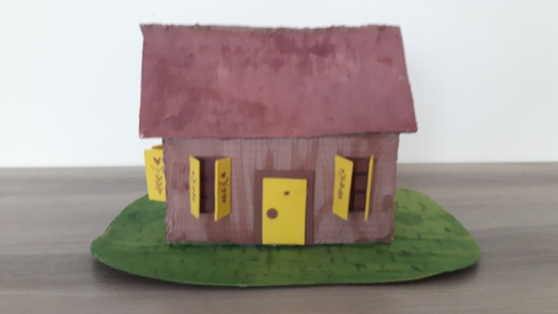
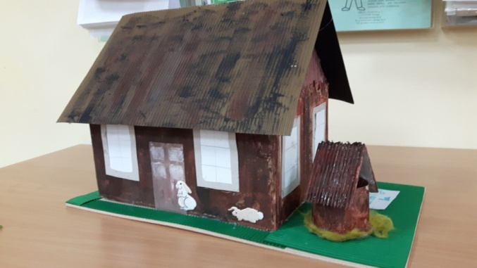

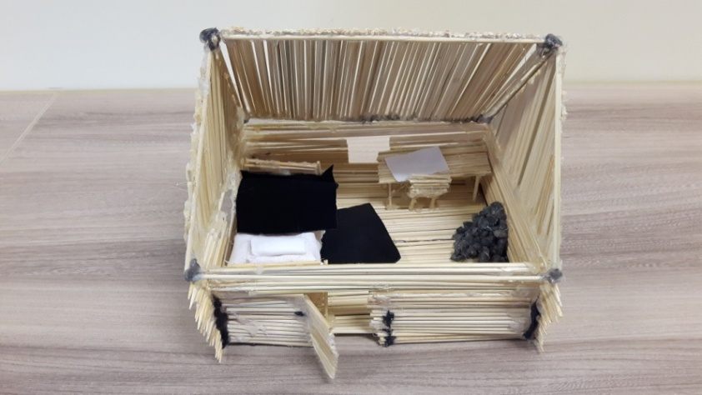
- Dzūkija (Dzūkija or Dainava (the latter name literally means "Land of songs")). Region in the southeast of Lithuania. Houses in Dzūkija were smaller than in other regions. They were one-ended or double- ended. Straw roof was composed of gable and four-slope roofs. Houses had not claddings. Only shutters were moderately decorated.
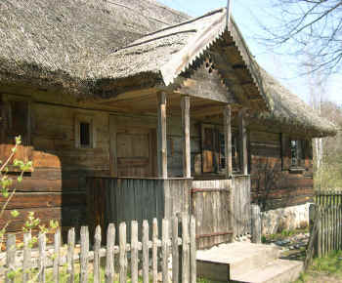
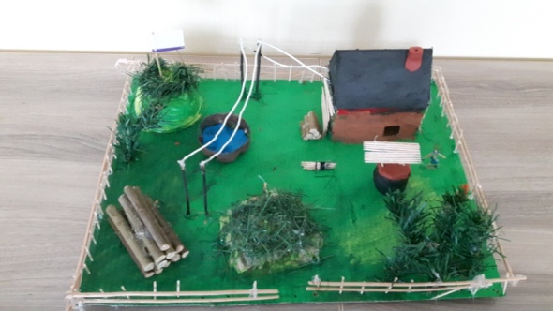
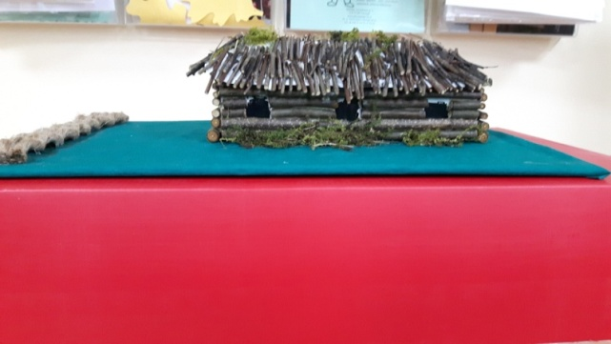

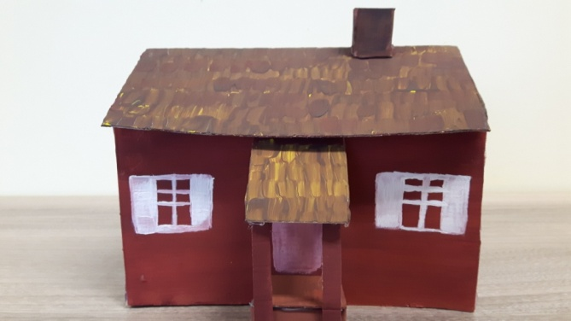
- Suvalkija (Sūduva or Suvalkija). Region in the southwest of Lithuania. A house in Suvalkija was called stuba. It was one- ended or double- ended. Windows had single-colored or two- coloured shutters dissected with flowers or hearts. A porch was built to the front door.
