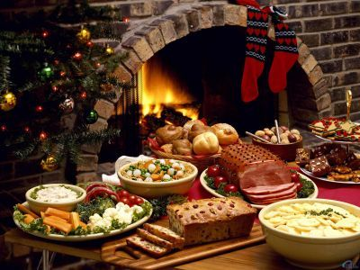

This brochure was prepared by students from SP10 Rzeszów   
as a part of European project “*Differences bring Us together”*

Differences bring Us together

# Religious Holidays in POland

Tło związane ze świętem Paschy

**Easter in Poland**

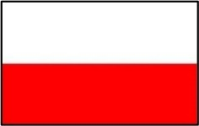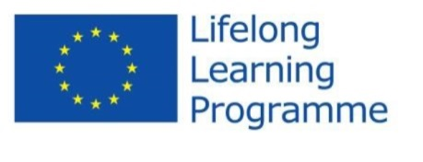 

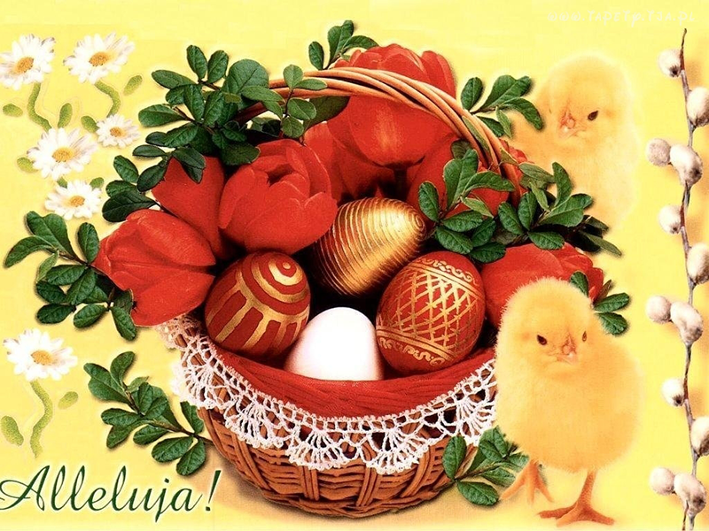

**WIELKANOCNE ZWYCZAJE  
JAK ZROBIĆ WIELKANOCNE PISANKI?**

**EASTER TRADITIONS.   
HOW TO PREPARE EASTER EGGS?**

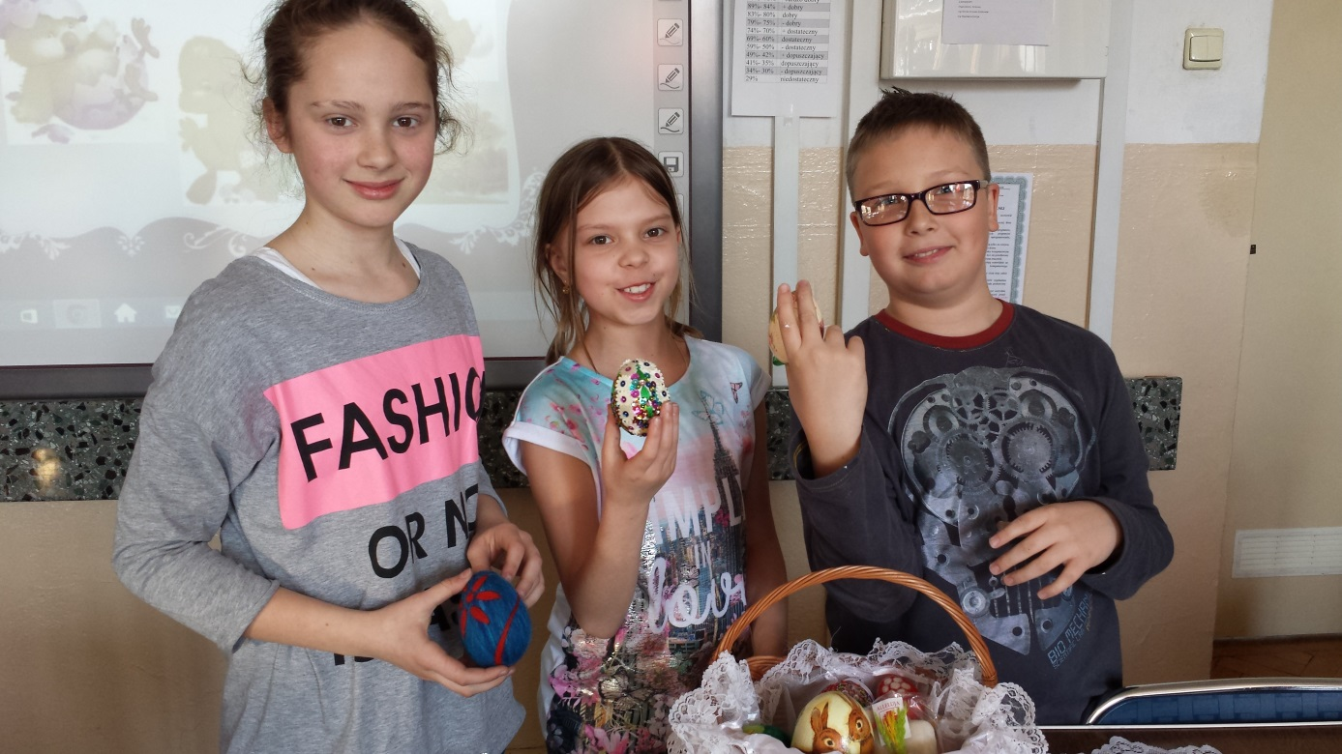Pięknie zdobione jaja są symbolem odradzającego się życia. Od wieków zdobią polskie stoły podczas świąt wielkanocnych. Wprawdzie przez lata sposoby barwienia i dekorowania jaj zmieniły się, ale tradycja pozostała. Najszybszą metodą barwienia jajek jest zanurzanie ich w gorącej wodzie, w której rozpuszczony został barwnik. Intensywność koloru zależy od tego, ile czasu jajo jest zanurzone w kąpieli oraz od koloru skorupki. Warto też pamiętać, że kolor możemy utrwalić, zanurzając jajka w occie lub spryskując pisanki lakierem do włosów.

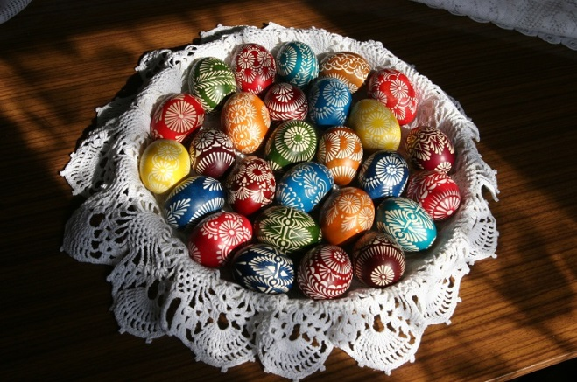**Beautiful decorated eggs are the sign of the reviving life. They have decorated Polish tables during Eastertime for ages. Although the ways of eggs colouring and decorating have been changed for years but tradition is still the same. The fastest way of eggs colouration is to plunge them in a hot water with a melt dye. The intensity of the colour depends both on the time of the egg plunging in a pigment and the colour of a shell. It's worth remembering that we can varnish the colour by plunging our eggs in vinegar or use hair spray.**

Piękne kolory skorupek można uzyskać, stosując naturalne barwniki roślinne. Świeżo wyciśnięty, lekko zakwaszony sok z buraka barwi pisankę na różne odcienie różu i czerwieni, sok z jagód – na fioletowo, wywar z suchych łusek cebuli – na wszystkie odcienie cieplej żółci aż do rudawego brązu, zaś woda, w której gotował się szczypiorek lub świeża zielona trawa – na zielono.

**You will get the beautiful colours of the egg-shells if you use plant dyes. A fresh, light sour beetroot juice colours an egg in different shades of pink and red. A berry juice makes the egg violet, a dry onion hulls – from all shades of hot yellow to reddish brown. Water with a boiled chive or fresh green grass makes the eggs green.**

Przepis na wydmuszkę

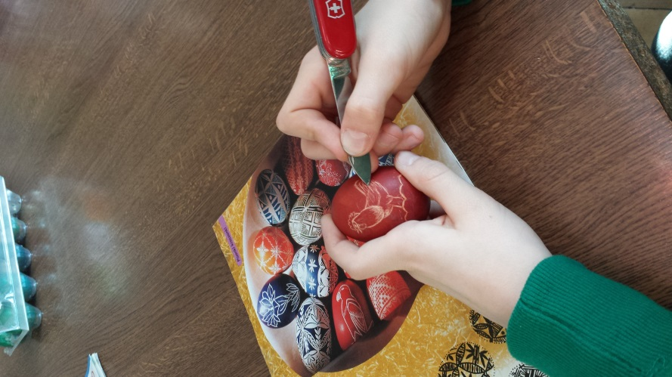Weź jajko, zrób dwie dziurki z obu stron, najlepiej igłą. Dmuchaj w jedną dziurkę. Poproś rodziców, żeby ci pomogli. Jak wyleci z jajka żółtko, to możesz pokolorować.

**A shell of a blown egg recipe**

**Take an egg, make two holes on two sides with a needle. Blow in one hole. Ask your parents to help you. If a yolk gets out of the egg, colour your egg.**

Woskowanie

Jeśli na czystą skorupkę naniesiemy wzór z roztopionego wosku, a następnie zanurzymy jajo w roztworze barwnika, to zabarwią się tylko odsłonięte fragmenty skorupki. Części ukryte pod woskiem nie zmienią koloru. Po wyjęciu jajka z kąpieli wystarczy zetrzeć wosk miękką ściereczką.

**Waxing**

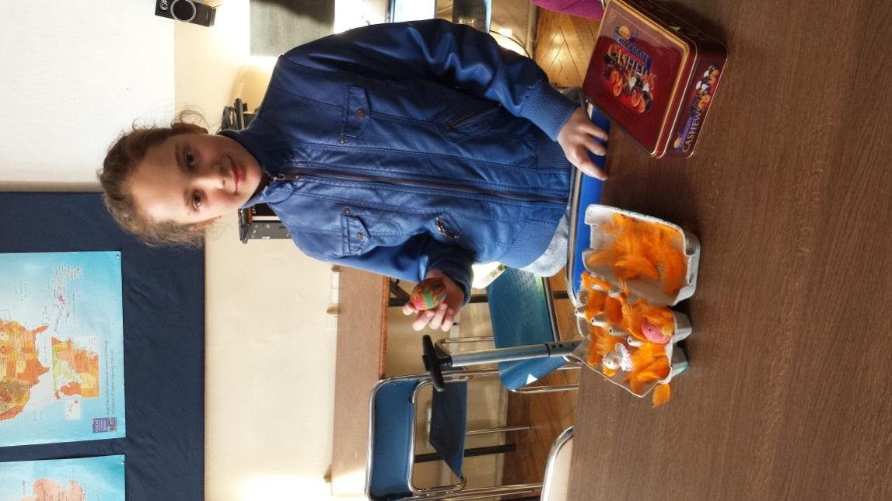**If we put a pattern from a melt wax on the egg-shell, next we plunge the egg in a dye, only open pieces of the shell will be coloured. The rest, hidden under the wax won't change the colour. You should remove the wax from the egg with a soft dish-cloth.**

Koronkowe wzory

Zabarwione na intensywny kolor skorupki można ozdobić misternymi wzorkami. Metoda jest prosta: wystarczy szpilką lub ostro zakończonym nożem „wydrapać” dowolne motywy. Uzyskany w ten sposób wzór jest tak subtelny, że przypomina delikatną koronkę. To metoda dla wytrwałych.

**Laces patterns**

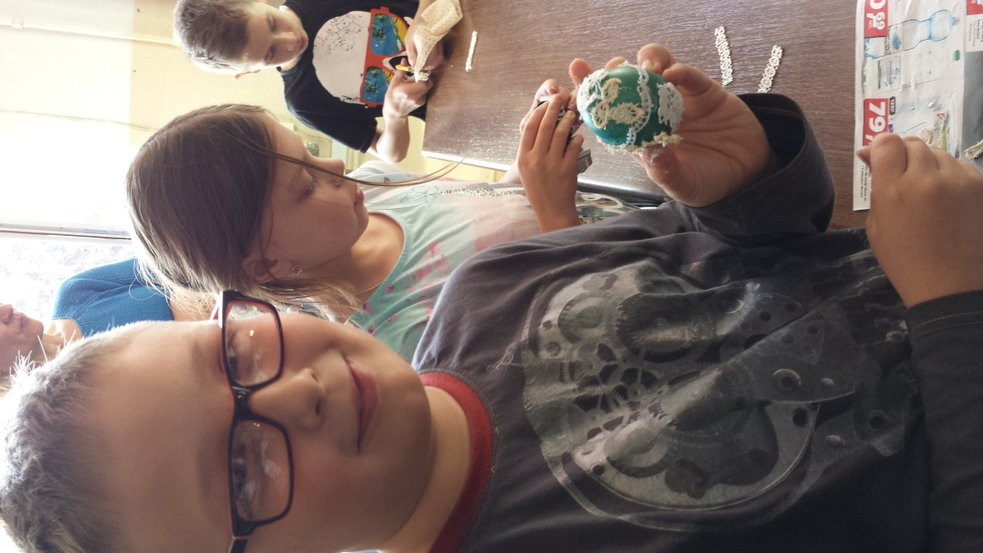**Strong coloured shells can be decorated with subtle patterns. The method is simple: one must engrave suitable ornaments with a pin or a sharp knife. This kind of pattern is very gentle and it reminds a light lace. But one must be patient, stubborn and determined a lot to do it!**

Pisanki – oklejanki

To współczesna metoda zdobienia pisanek. Możesz z barwnego papieru, cienkiego materiału o ciekawym wzorze lub kolorowej samoprzylepnej folii wyciąć fantazyjne elementy, a potem nakleić je na skorupkę tak, jak podpowiada im wyobraźnia.

**A stuck Easter eggs**

**This is a modern way to decorate Easter eggs. You may use a beautiful paper, a delicate material with an interesting pattern or a colourful selfstuck foil. Try to cut amazing elements, then stick them on a shell. Use your imagination!**

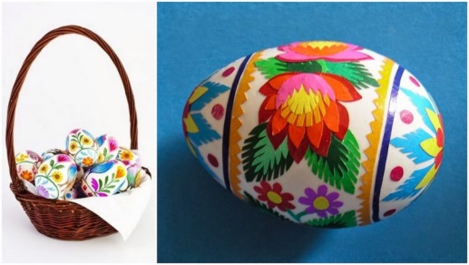**WIELKANOC**

Najważniejsze i najstarsze święto chrześcijaństwa, obchodzone na pamiątkę Zmartwychwstania Chrystusa. Obchody religijne Wielkanocy rozpoczyna odbywająca się wczesnym rankiem procesja i msza, w Kościele katolickim zwana rezurekcją. W tym dniu spożywa się uroczyste śniadanie w gronie rodzinnym, poprzedzone składaniem sobie życzeń. Wielkanoc wieńczy okres Wielkiego Postu i poprzedzający ją Wielki Tydzień. Jest czasem radości (symbolizuje ją biały kolor szat liturgicznych). Z Wielkanocą wiążą się liczne religijne i ludowe obrzędy (święcenie pokarmów, pisanki, śmigus-dyngus). Święta Wielkanocne mają bogatą tradycję. Są niezwykle barwne, towarzyszy im wiele obrzędów. Po wielkim poście – kiedyś bardzo ściśle przestrzegany – ludzie z niecierpliwością czekali na odmianę. O wielu wielkanocnych obyczajach pamiętamy także dzisiaj. Dzięki nim świąteczne dni są bardziej radosne.

**EASTER**

**It's the most important and the oldest Christian celebration. Easter is held in remembrance of Jesus Christ Resurrection. Every year on Easter Sunday, at dawn, there is a great procession and a Mass (called Resurrection) to start a religion festival in the Roman Catholic Church. On Sunday a solemn breakfast is eaten by families and the closest friends. Before this meal members of the families wish luck and all the best. Easter finishes Lent and the Holy Week. It's the time of joy, which is shown by a white colour of a chasuble. A lot of religious and folk customs are connected with Easter, for example food consecrating, Easter eggs decorating, Easter Monday). Easter has a splendid tradition. In the past Lent was taken very seriously. People were looking forward to having some change. Nowadays we remember about many Easter customs. According to them Easter days are more cheerful.**

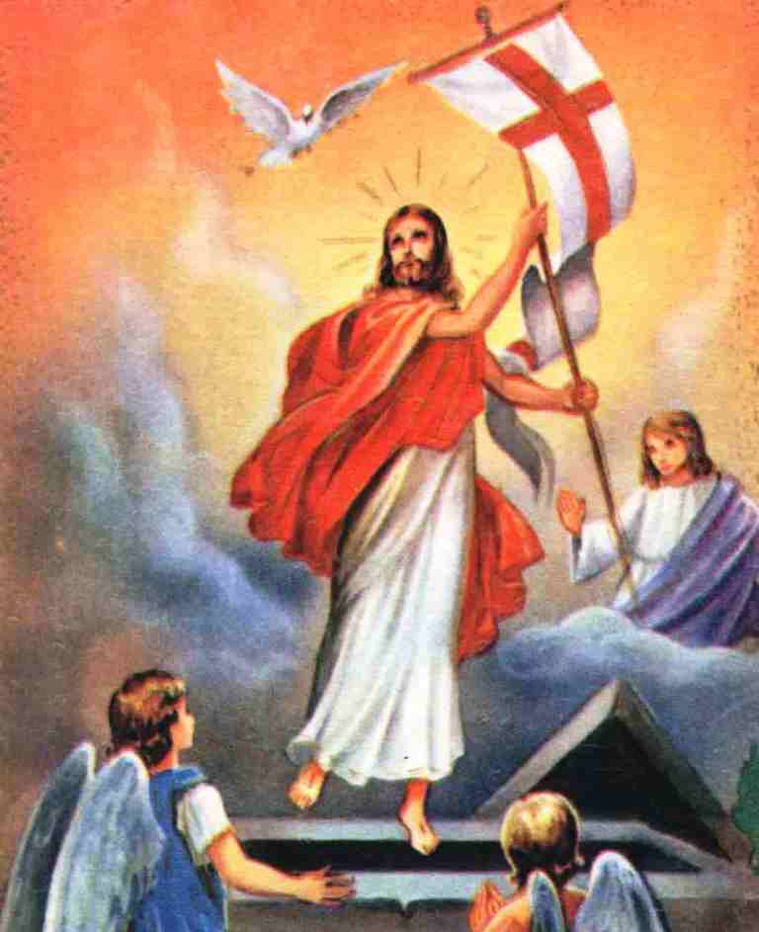**ZWYCZAJE I TRADYCJE WIELKANOCNE**

Palemki na szczęście. Wielki Tydzień zaczyna się Niedzielą Palmową. Palemki – rózgi wierzbowe, gałązki bukszpanu, malin, porzeczek – ozdabiano kwiatkami, mchem, ziołami, kolorowymi piórkami. Po poświeceniu palemki biło się nią lekko domowników, by zapewnić im szczęście na cały rok. Połkniecie jednej poświeconej bazi wróżyło zdrowie i bogactwo. Zatknięte za obraz lub włożone do wazonów palemki chroniły mieszkanie przed nieszczęściem i złośliwością sąsiadów.

**Easter customs and traditions**

**Palms for luck.**

**The Palm Sunday begins the Holy Week. Little palms - willow twigs, the branches of a box, raspberries, currants - were decorated with flowers, moss, herbs, colourful feathers. After palms consecrating the members of the household were hit slightly with the palms to protect persons from evil and have luck all year long. When someone swallowed one blessed catkin – it meant to be healthy and rich.**

Świąteczne porządki

Przed Wielkanocą robimy wielkie świąteczne porządki nie tylko po to, by mieszkanie lśniło czystością. Porządki mają także symboliczne znaczenie – wymiatamy z mieszkania zimę, a wraz z nią wszelkie zło i choroby.

**Easter orders**

**People make special, Easter orders not only to have clean flats or houses. The orders have a symbolic meaning – getting rid of winter, evil and illnesses.**

Topienie Judasza

Kolejnym ważnym dniem Wielkiego Tygodnia jest Wielka Środa. Młodzież, zwłaszcza chłopcy, topili tego dnia Judasza. Ze słomy i starych ubrań robiono wielka kukłę, którą następnie wleczono na łańcuchach po całej okolicy. Przy drodze ustawiali się gapie, którzy okładali kukłę kijami. Na koniec wrzucano „zdrajcę” do stawu lub bagienka. Wymierzanej w ten sposób sprawiedliwości stawało się zadość.

**The drowning of Judas**

**Holy Wednesday is an important day of the Holy Week. In the past young boys were drowning Judas this day. They prepared a big effigy, using straw and old clothes. The doll was pulled in chains through the streets. A crowd gathered, stared at it and hit the doll with some sticks. At the end Judas, the traitor was thrown into a pond or mud. Justice was done!**

Święconka

Wielka Sobota była dniem radosnego oczekiwania. Koniecznie należało tego dnia poświęcić koszyczek z jedzeniem. Nie mogło w nim zabraknąć baranka (symbolu Chrystusa Zmartwychwstałego), mięsa i wędlin (na znak, że kończy się post). Święcono też chrzan, – bo „gorycz męki Pańskiej i śmierci została zwyciężona przez słodycz zmartwychwstania”, masło – oznakę dobrobytu – i jajka – symbol narodzenia. Święconkę jadło się następnego dnia, po rezurekcji. Tego dnia święcono też wodę.

**Traditional display of festive food on a separate table at Easter**

**Holy Saturday is a day of cheerful waiting... During this day people must have festive delicacies blessed by the priest in church. They carry food in a basket. There is: a ram (the symbol of Jesus Christ Ressurection), some meat (to finish Lent), a horseredish (the sign both of Passion sadness and Ressurection joy), butter (for prosperity) and eggs (the emblems of new life). Water is blessed on Holy Saturday too. The consecrated food is eaten at Easter Sunday festive luncheon.**

Wielka Niedziela – dzień radości

W Wielką Niedzielę poranny huk petard i dźwięk dzwonów miał obudzić śpiących w Tatrach rycerzy, poruszyć zatwardziałe serca skąpców i złośliwych sąsiadów. Po rezurekcji zasiadano do świątecznego śniadania. Najpierw dzielono się jajkiem. Na stole nie mogło zabraknąć baby wielkanocnej i dziada, – czyli mazurka.

**Holy Sunday – the day of happiness**

**It is said that the sound of morning fireworks and church-bells woke sleeping knights in the Tatras mountains. This special time moved the hearts of niggards and spiteful neighbours. After the Ressurection Mass everybody sat at the table. People wished luck, shared eggs with each other. They tasted Easter cakes.**

Lany poniedziałek

Lany poniedziałek, śmigus-dyngus, święto lejka – to zabawa, którą wszyscy doskonałe znamy. Oblewać można było wszystkich i wszędzie. Zmoczone tego dnia panny miały większe szanse na zamążpójście. A jeśli któraś się obraziła – to nieprędko znalazła męża. Wykupić się można było od oblewania pisanką – stąd każda panna starała się, by jej kraszanka była najpiękniejsza. Chłopak, wręczając tego dnia pannie pisankę, dawał jej do zrozumienia, że mu się podoba.

**Easter Monday**

**There is a well known fun on Easter Monday. You are allowed to pour water on whoever and wherever you want. Watered girls had more chances to get married soon. If they were offended, they wouldn't get married at all. But if the girl gave a boy an Easter egg, she wouldn't be watered. Each girl prepared the most beautiful egg she had ever seen. The boy, who delivered the Easter egg to his girlfriend, tried to tell her 'the words of love'.**

Wielkanocne jajo

Jajo – króluje na wielkanocnym stole, jest symbolem życia i odrodzenia. Tradycja pisanek i dzielenia się święconym jajkiem sięga daleko w przeszłość. Już starożytni Persowie wiosną darowali swoim bliskim czerwono barwione jaja. Zwyczaj ten przyjęli od nich Grecy i Rzymianie. Rumuńskie przysłowie ludowe mówi:, „Jeśli my, chrześcijanie zaprzestaniemy barwienia jaj na czerwono, wówczas nastąpi koniec świata”. Czerwone pisanki mają ponoć moc magiczną i odpędzają złe uroki, są symbolem serca i miłości. Jajko jest formą najbardziej doskonałą. Zawiera wszystkie konieczne dla odżywienia organizmu składniki: białko, tłuszcz, sole mineralne i witaminy. Ma około 100 kalorii.

**An Easter egg**

**An egg, which is characteristic for an Easter table, is the symbol of life and rebirth. The tradition of decorating and eating a blessed egg started in the past. The ancient Persians gave red dyed eggs to their relatives. Greeks and Romans took this custom from Persians. The Rumanian proverb says: „If we, the christians, stop colouring eggs in red, the end of our world will come soon.” The red eggs have a magic power. They are able to banish an evil. They are an emblem of heart and love. The egg is the most perfect form. It includes all ingriedents, which are necessary for our survival: protein, oil, mineral salts, vitamins. It has about 100 calories.**

**Easter games:**

1. **Egg rolling – children take their eggs to the top of the hill and roll them down. The first egg to get to the foot of the hill is the winner.**
2. **Egg hunt – children look for decorated or chocolate eggs in their house or garden. They try to find all of them as quickly as possible.**
3. **Egg fight – you need to hold your hard-boiled egg firmly and use it to hit your friends' eggs. You win if your egg breaks their eggs.**
4. **Egg dance – persons put several eggs on the floor and dance among them with their friends. They mustn't step on the eggs.**

**Links:** [**Easter tradition**](http://difbruspo.wix.com/poland#!Easter-traditions/c1lb3/5537807b0cf2836c87e681df)

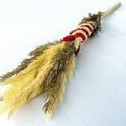 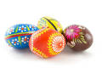 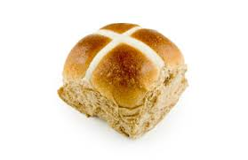

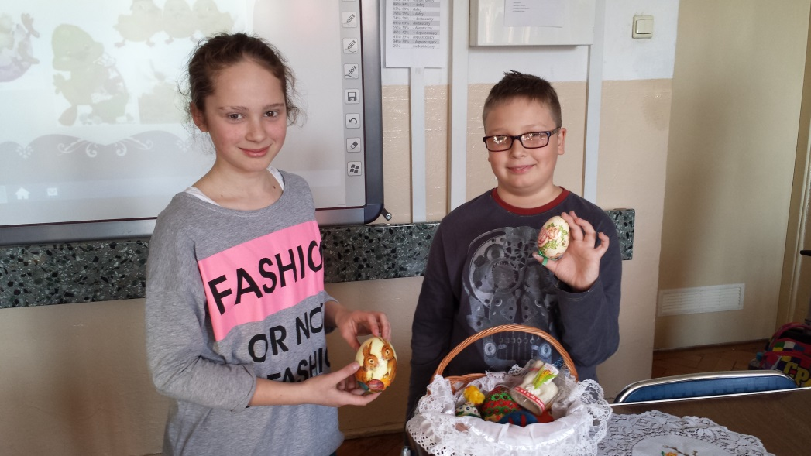**A few photos from the project workshop**

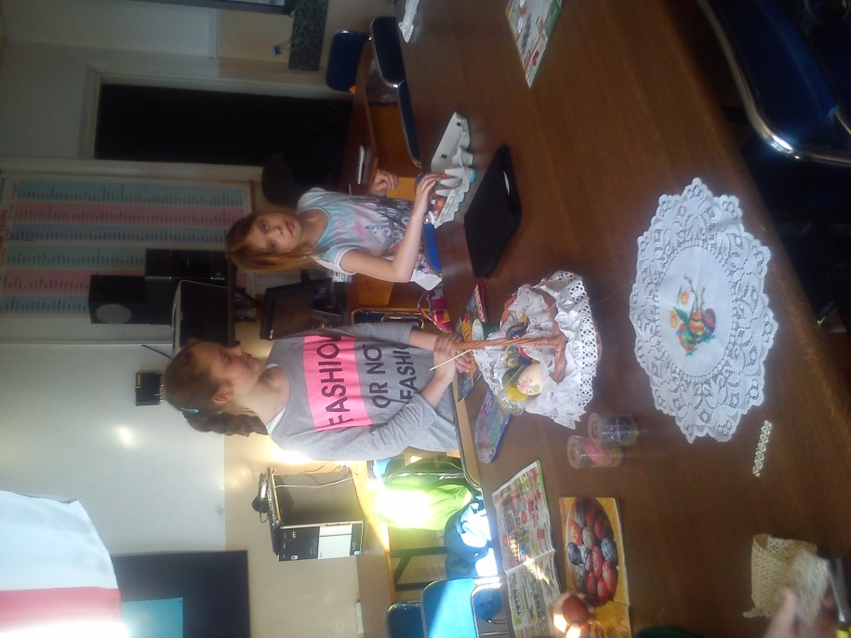

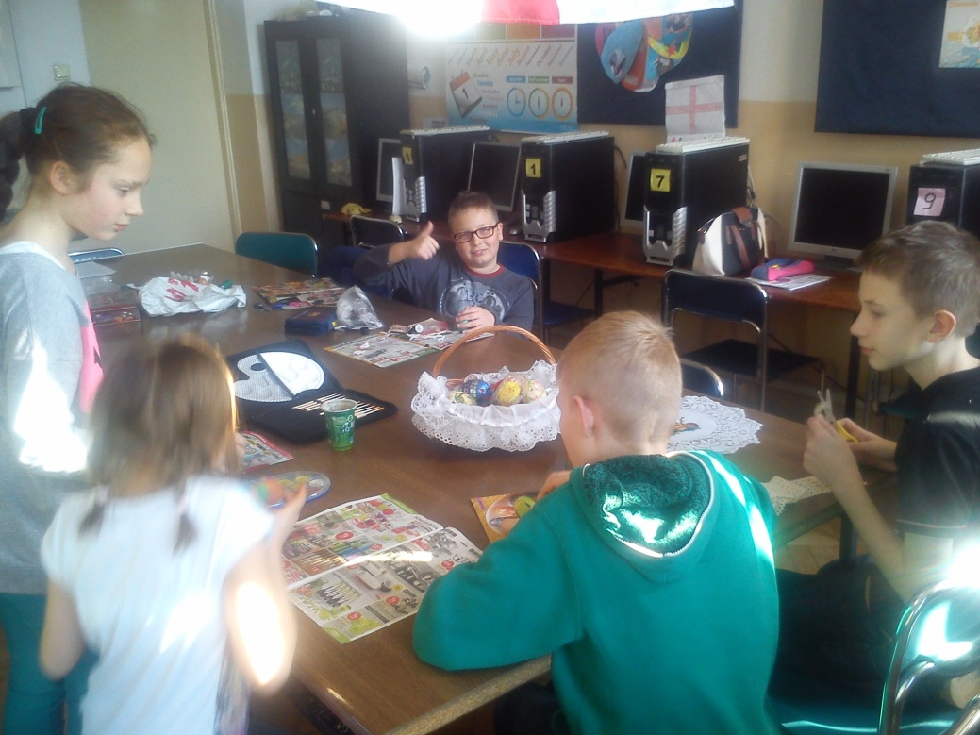

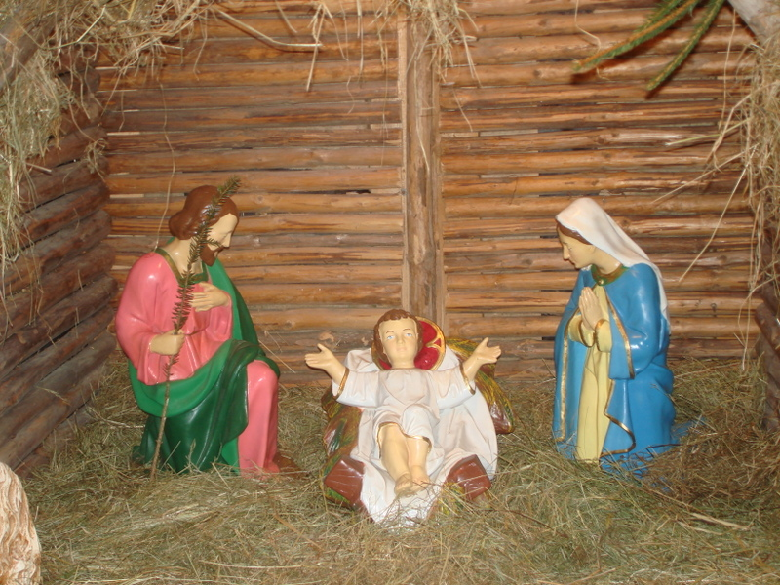**Christmas in Poland**

*Motto:*

*„Nothing is stronger than custom” (Ovid)*

*„Custom is almost a second nature” (Plutarch)*

**Christmas in Poland**

The role tradition plays in forming man’s identity is unimaginable because the key to the present is in the past. If we don’t cultivate out traditions we will start disrespecting our forefathers.

The Poles have celebrated Christmas for ages. Some Christmas customs and traditions are quite extraordinary. It is a special time of happiness, joy, kindness and peace to everyone. 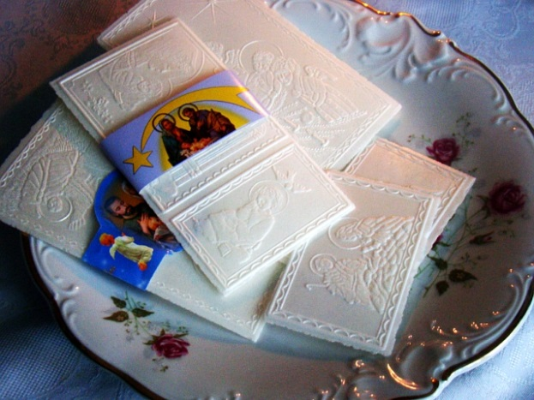People seem to forget all their problems and quarrels. They only enjoy spending time together – with family and friends.

There are numerous signs even at the beginning of December that Christmas is approaching. The time of waiting for baby Jesus is called Advent. The shop windows are decorated. Town streets are lit by colored lamps. People buy presents, choose ‘season’ cards. They are in a hurry to be ready on time. Everyone starts to make plans for the coming holiday. The unique atmosphere of excitement and hope is felt everywhere.

At last, Christmas Eve comes. The final preparations for the holiday are made. Doing shopping is completed, cakes are baked. Christmas trees are set up in every house. They are decorated with paper chains, colorful balls, bells and different toys. Children look forward to having surprise and gifts. Bunches of mistletoe are suspended from the ceiling or from lamp shades. According to popular custom any girl or woman caught standing under the mistletoe may be kissed without her permission. Christmas Eve is a special day. It is said everything that might happen on this day it might have an influence on the whole year. It is believed that the first person who enters the house can ensure welfare to all members of the family, especially if it is a man.

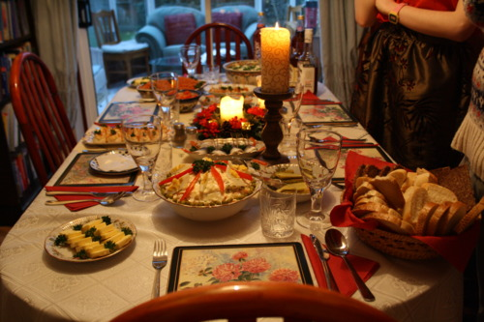When the first star appears and shines in the sky, people take seats at the Christmas table. The table cloth is white and hay is spread on it. You aren’t allowed to forget about leaving an empty plate for an unexpected guest. Christmas Eve supper is proceeded by greetings. The members of the family wish luck, health and prosperity to each other. They share the holy wafer.

In our Polish tradition it is very important to have twelve dishes during Christmas Eve meal – to commemorate twelve apostles. The most popular dishes are red borsch, cabbage, mushrooms, fish (usually carp) and poppy-seed cake. Sometimes the biblical story about Jesus Christ birth is read before eating. There is also a custom of giving presents hidden under the Christmas tree. At midnight many people go to church for special Christmas Mass. They sing carols and see Christ-child’s crib. This night is full of magic and miracles. It is believed that animals can speak with human voices. Something wonderful may happen to somebody!

The first day of Christmas (25th of December) is celebrated at home with family, friends and acquaintances. There is no work at all. It is the full time of resting. On that day carol-singers dressed as King Herod, Death and devil visit a lot of houses. They not only sing carols but recite poems or play a short drama from the Bible scenes too.

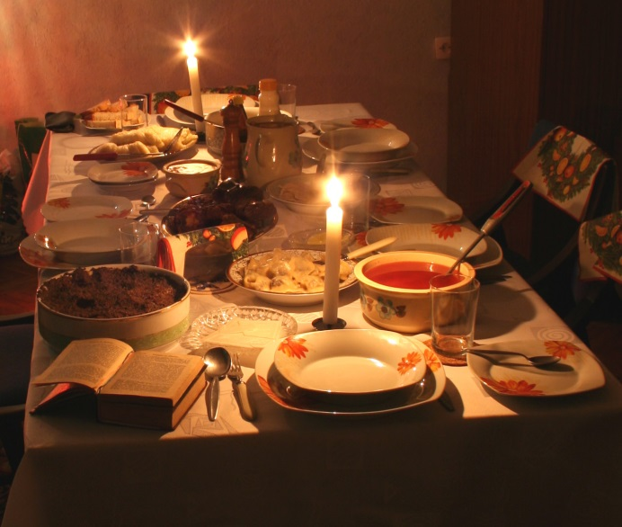The second day of Christmas (26th of December) is called ‘Saint Szczepan’s Day’ and it is sacrificed to the first martyr in the Roman-Catholic Church. The Polish people spend this day in many different ways, usually at the table - talking, singing carols or visiting friends. It is known that Carnival has just begun.

Christmas is a very happy time. Its customs and traditions may differ between different countries and continents, but they have one thing in common – they are a source of joy and love for all people around the world.

Links:

[See our students during Christmas workshops](https://plus.google.com/photos/100951796187829504751/albums/6098328788052511793), [Christmas gingerbread](http://difbruspo.wix.com/poland#!Christmas-traditions/c1lb3/DD8A9158-843C-46C6-B5EF-AB9F241E6604)

[Photos from the Nativity play](https://plus.google.com/photos/100951796187829504751/albums/6109009370657396833?banner=pwa)

[Information about  School Contest of the Nativity Play](http://difbruspo.wix.com/poland#!The-Nativity-play/c1lb3/552007e00cf21e26bad24c09)

Religious festivities in Greece

# Christmas

The festive period lasts from November 30 to January 6 (Epiphany) on the [Greek calendar](http://en.wikipedia.org/wiki/Public_holidays_in_Greece). December 25 and 26 is a [public holiday in Greece](http://en.wikipedia.org/wiki/Public_holidays_in_Greece). In [Greek](http://en.wikipedia.org/wiki/Greek_Language), Christmas is known as ‘’Christougena’’ and people wish ‘’Merry Christmas’’ to each other saying ‘’Kala Christougenna’’. Most families set up Christmas trees and shops have decorations and lights. Presents are placed under the Christmas tree and are opened on January 1, St Basil's Day. In Greek tradition, Basil’ s name was given to Father Christmas and is supposed to visit children and give presents on January 1 (when Basil's memory is celebrated), unlike other European traditions, where this person is Saint Nicholas and comes every Christmas. Carol singing is another tradition on Christmas and New Year’s Eve. The Christmas meal usually includes lamb or pork and desserts such as ‘’[kourabies](http://en.wikipedia.org/wiki/Kourabies)’’ and ‘’[melomakarona](http://en.wikipedia.org/wiki/Melomakarona)’’.

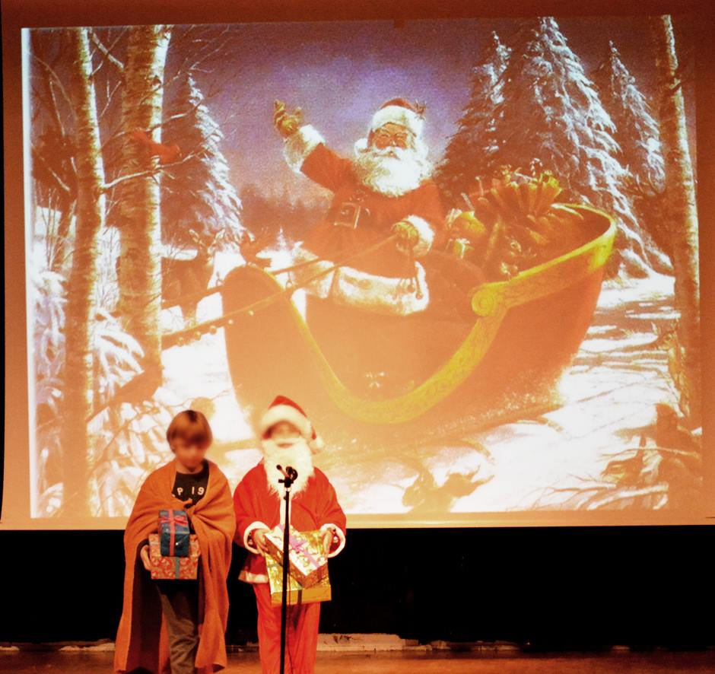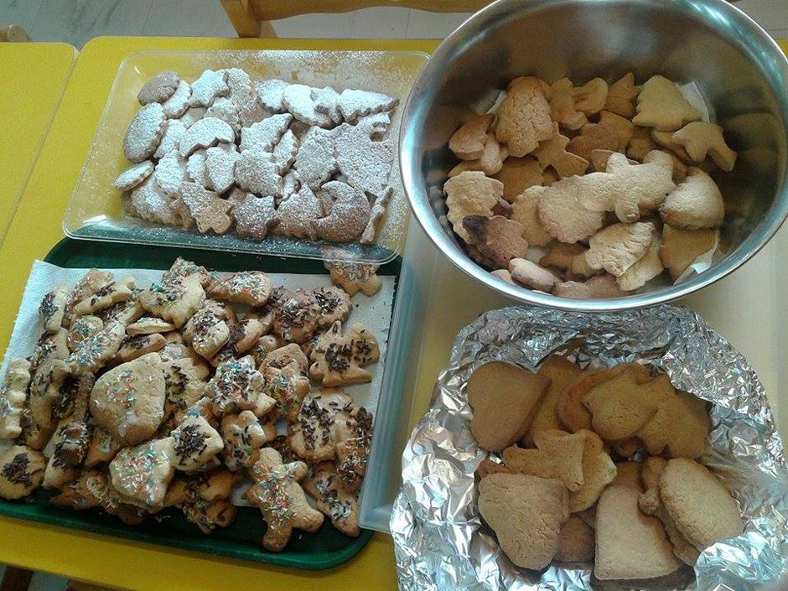

Christmas Eve on December 24 and 23 housewives make the Christmas cake with a cross in the middle. Children singing carols from house to house. They play drums and triangles as they sing. Sometimes they will also carry model boats decorated with nuts which are painted gold. Carrying a boat is a very old custom in the Greek islands. People give them money or sweets. People go to church at early the morning of Christmas of December 25. In many Greek cities and ports is decorated the traditional Christmas boat and in many central squares of the country a big Christmas tree, where take place many of the Christmas festivals.

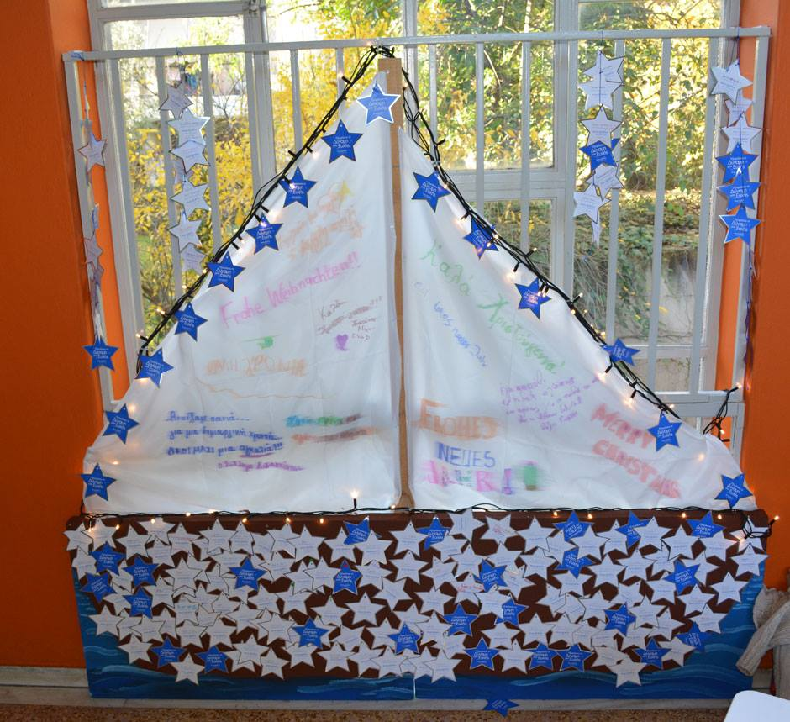

This is believed to keep ‘’Kallikantzaroi’’ (bad spirits) away. The ‘’Kallikantzaroi’’ are meant to appear only during the 12-day period from Christmas to Epiphany. They are supposed to come from the middle of the earth. They do things like putting out fires and making milk go off. Having a fire burning through these twelve days is also meant to keep them away.

People in Greece also celebrate Epiphany on the 6th January. In Greek Orthodox Church, Epiphany celebrates Jesus’ baptism when he was a man. It’ s also known as ‘’The Blessing of the Waters’’. There are many events throughtout the country where young men dive into really cold lakes, rivers and the sea to try to be the first to get a cross which has been blessed by a priest and thrown into the water. Whoever gets the cross first is meant to have good luck during the coming year. Epiphany festivals also include blessings of boats and ships, music, dancing and lots of good.

# Easter

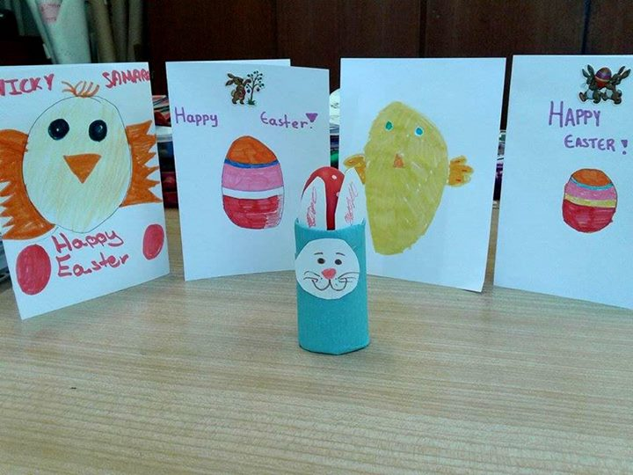Greek Easter, the country's most important religious festival, arrives accompanied by the smells of spring, the rebirth of nature and the flower-carpeted ground. The determination of the date of Easter is governed by a computation based on the vernal equinox and the phase of the moon. In Greek, Easter is called ‘’Pascha’’, meaning Passover: it is the eternal Passover from death to life and from earth to heaven.

Easter is the most sacred and celebrated of all Greek holidays. It begins with a 40-day fast. Of the 40 days, one week is chosen for the complete fast. During that time only natural foods are eaten. No meats, dairy, fish, poultry or dishes that are prepared with these foods can be eaten. Shellfish can be eaten, however three days a week are meatless days during the remaining weeks of the fast. During Holy Week complete fasting is to take place.

On Good Friday, the day of mourning, the ‘’Epitaphios’’, the tomb of Christ with its icon, decorated with flowers, is taken out of the church and carried around the village followed by a slow procession. After the procession, it returns to the church where the believers kiss the image of the Christ. During the night of the Holy Saturday, everybody dresses well and goes to the church where a ceremony is hold. Just before midnight, all of the lights of the church are turned off, symbolizing the darkness and silent of the tomb, while the priest lights a candle from the Eternal Flame, sings the psalm ‘’Christos Anesti’’ (meaning ‘’Christ has risen’’) and offers the flame to light the candles of the people. Everyone passes the flame one to another. The bells ring continuously and people throw fireworks.

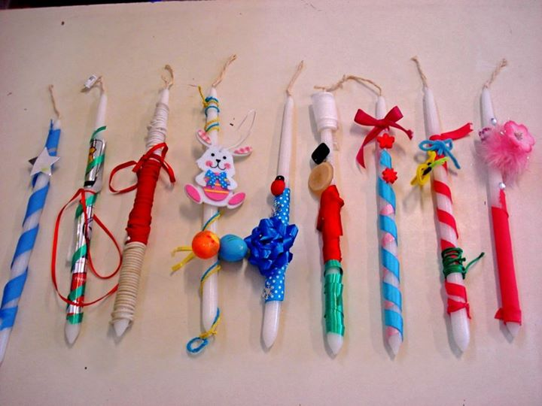

The red eggs for just after the Resurrection and the traditional Resurrection soup, "mageritsa," will be the wife's first concern, and her preparations will begin early in the Holy Week. That preparation means the cleaning and decoration of the house, the baking of the Easter biscuits and ‘’tsoureki’’ (Easter cake) and the dyeing of the eggs.

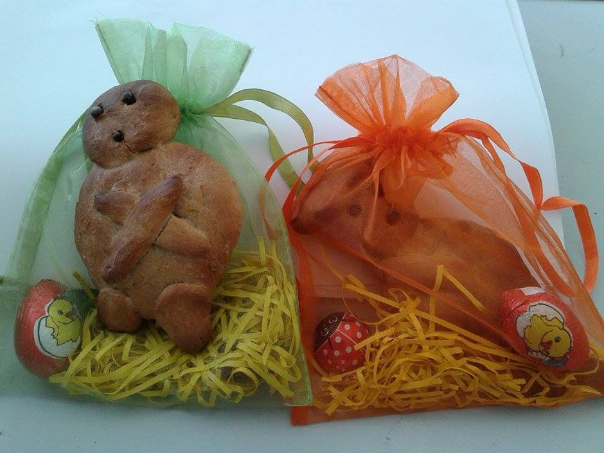

During Holy Week the churches are full each evening as the people follow, once more the Passion of Our Lord. Then at midnight on the Saturday the bells ring out joyfully: the faithful, candles lit, can celebrate the Resurrection.

On Easter Sunday, spit-roast lamb is the centerpiece of the table. In the early morning, the spits will be turning in the courtyards and under the shady trees as the lamb "kokoretsi" is slowly cooked, and the aroma of the roasting lamb wafts from one end of Greece to the other. The red eggs are knocked and the traditional phrase "Christ is risen" are heard all around the table.

**RELIGIOUS HOLIDAYS IN TURKEY**

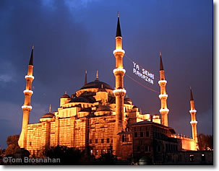

**Islamic holidays** arrive according to the lunar **Hijri calendar**, which is 11 days shorter than the common solar (Gregorian) year.

The two most important Islamic holidays are [Kurban Bayramı](http://www.turkeytravelplanner.com/Religion/kurban_bayrami.html) and [Ramazan](http://www.turkeytravelplanner.com/Religion/ramazan.html), which also contain [national public holidays](http://www.turkeytravelplanner.com/WhenToGo/national_holidays.html)

Islamic holidays **begin at sundown**, last until sundown on the following calendar day, and the important public holidays are usually preceded by a **half-day vacation**called *arife* ("preparation"). Offices, banks and businesses may **close at noon** on the day of *arife,*with the festivities beginning at sunset*.*

|  |  |
| --- | --- |
| |  | | --- | | **Ramazan/Ramadan in Turkey** | |
|  |
| |  |  |  |  |  |  |  | | --- | --- | --- | --- | --- | --- | --- | | Padisah Macuncu, Ramazan, Istanbul, Turkey [***Padişah Macunu*:** a taffy treat during Ramazan in Turkey.](http://www.turkeytravelplanner.com/details/Food/index.html)  [Minaret, Gaziantep, Turkey](http://www.turkeytravelplanner.com/Religion/prayer_times.html) |  | The 30-day [Islamic](http://www.turkeytravelplanner.com/Religion/Islam.html) holy month of **Ramazan** (RAH-mah-zahn, called **Ramadan** in other countries) is a time of fasting, prayer and celebration. [(Here are**Ramazan dates.**)](http://www.turkeytravelplanner.com/Religion/ramazan_dates.html) It can also [affect your travel plans](http://www.turkeytravelplanner.com/Religion/ramazan_travel.html).  **Fasting...**  Fasting means **letting nothing pass the lips**: no [food, drink](http://www.turkeytravelplanner.com/details/Food/index.html), chewing gum, [tobacco](http://www.turkeytravelplanner.com/details/Tobacco/index.html) smoke or, for the strictly observant, not even licking an envelope or postage stamp from sunrise to sunset. Observant Muslims also refrain from sexual intercourse during daylight in the holy month.  Most Muslims, whether strictly observant or not, use the holy month and the stricture of fasting to help them **examine their lives**, to remind themselves of**virtues** like charity, compassion and forgiveness, and to avoid vices like cupidity, selfishness and dishonesty.  **Many Turks fast from sunrise to sunset** during Ramazan. Restaurants are less busy at lunch, and there's even less [Turkish tea](http://www.turkeytravelplanner.com/details/Food/TurkishTea.html) in evidence—which is amazing.  If you're in Turkey during Ramazan, it's polite to**refrain from eating and drinking in public** during daylight hours. Rather, do it inside a restaurant, tea house, cafe (some of which will be operating, except in[Konya](http://www.turkeytravelplanner.com/go/CentralAnatolia/Konya/index.html)), or other private or semi-private area.  Muslim restaurant and cafe staff, who may be fasting themselves, will understand if you are non-Muslim and will be happy to serve you. Some eateries may cover their windows with curtains so as not to distract those fasting by the sight of others eating.   |  |  | | --- | --- | |  | [Blue Mosque, Istanbul, Turkey](http://www.turkeytravelplanner.com/go/Istanbul/Sights/Sultanahmet/BlueMosque.html) | |  | *Mosques are busy during Ramazan* |   **Feasting!**  **Ramazan**is also a**time of celebration**, and **after sunset the feasting begins**with a ceremonial "break-fast" light meal called ***Iftar*.**  It always includes **freshly-baked flat *pide* bread**, and usually soup, pickled vegetables, olives and other easily-prepared edibles. Elaborate dinners are held later in the evening.  Strings of colored lights festoon trees and buildings,**mosques are illuminated** and crowded with worshippers.  A **carnival atmosphere prevails** with temporary booths selling religious books and paraphernalia, traditional snacks and stuff for the kids.  In the middle of the night **drummers** circulate through towns and villages to wake sleepers so they can prepare ***Sahur****,*the big **early-morning meal** to be eaten before the fast begins again at sunrise. They tend to make their noise around 02:30 and 03:00 am, and they make sure everyone hears them. If you don't want to awaken, have earplugs, close your hotel room windows, or both.  Many restaurants offer special **banquet-like Ramazan menus** at night.  Some restaurants which normally serve [alcoholic beverages](http://www.turkeytravelplanner.com/details/Food/index.html) may refrain from doing so during the holy month, offering fruit juices and other drinks instead. It would be polite for you to observe this stricture if you are in an establishment where others are refraining from alcohol. (In some restaurants, alcohol service may resume after the evening's main meal is largely concluded.)  **Non-Muslims are welcome** and usually **invited** to join in the evening celebrations, which are **great fun**. Enjoy this special time!  Here are the [**dates for Ramazan**](http://www.turkeytravelplanner.com/Religion/ramazan_dates.html), and here is how the holy month may [affect your travel plans](http://www.turkeytravelplanner.com/Religion/ramazan_travel.html).  Ramazan is followed by the three-day holiday of[**Ramazan (Şeker) Bayramı**](http://www.turkeytravelplanner.com/Religion/seker_bayrami.html). [***More...***](http://www.turkeytravelplanner.com/Religion/seker_bayrami.html) **Ramazan Bayramı** is the three-day holiday that follows the end of the holy month of [**Ramazan**](http://www.turkeytravelplanner.com/Religion/ramazan.html). ([Here are the**dates**.](http://www.turkeytravelplanner.com/Religion/ramazan_dates.html))  Called ***Eid es-Seghir*** in many other [Muslim](http://www.turkeytravelplanner.com/Religion/Islam.html) countries,**Ramazan Bayramı**(sometimes called**Şeker Bayramı**[sheh-KEHR bah-yee-rah-muh, "Candy Holiday"]) starts at sunset on the last day of [Ramazan](http://www.turkeytravelplanner.com/Religion/ramazan.html), and celebrates the completion of the holy month of fasting.  In Turkey, it is an **official national holiday**. On the last day of Ramazan, most offices and businesses close after lunch for "preparation" (arife, ah-ree-FEH).The three-day holiday itself begins at sunset on that day, and lasts until sunset on the third day. So if the last day of Ramazan is Monday, the holiday begins Monday sunset and lasts until Thursday sunset.  **Offices**close for the half day of arifeand for the three days of holiday.  **Museums, archeological sites and similar visitor sights close for the first full day of the holiday**, but are usually open on the second and third days, and may be particularly busy with visitors. Special lower holiday admission fees may apply.  **Transport** may be on holiday (Sunday) schedules, at least for the first day of the holiday. Transport services may be particularly busy as people travel for vacation, so reserve your seats in advance.  On the last day of [Ramazan Bayramı](http://www.turkeytravelplanner.com/Religion/seker_bayrami.html), transport may be busy as holiday travelers return home.  In Turkey, **Ramazan Bayramı**is a time for sending greeting cards to friends and loved ones, paying visits, and enjoying a lot of sweets. Everyone enjoys drinking lots of [Turkish tea](http://www.turkeytravelplanner.com/details/Food/TurkishTea.html) and [coffee](http://www.turkeytravelplanner.com/details/Food/TurkishCoffee.html) in broad daylight after the 30 days of daylight **fasting** during [Ramazan](http://www.turkeytravelplanner.com/Religion/ramazan.html). | |

**Kurban Bayramı in Turkey**

Called *Eid el-Adha* or *Eid el-Kebir*in Arabic, **Kurban Bayramı** (koor-BAHN bahy-rah-muh) is the **most important** [**Islamic religious festival**](http://www.turkeytravelplanner.com/WhenToGo/IslamicHolidays.html)**of the year**, and a **4 or 5-day** **public holiday** in Turkey. It will affect your travel plans, so be prepared for it. [(Here are the**dates**.)](http://www.turkeytravelplanner.com/Religion/kurban_bayrami_dates.html)

Kurban Bayramı, which starts on 10 Zilhicce (Dhul-hijja)in the Islamic lunar Hijri calendar, is also the time of the annual **pilgrimage to Mecca** ***(Haj)***, so both domestic and international **travel is intense** in Turkey at this time.

Kurban Bayramı doesn't mean you shouldn't go to Turkey. You should **plan for the holiday**, though. Depending upon where you travel, you may find it changes your plans very little. Here's what to do:

**1. Plan not to travel on the first or last days of the holiday period**. If you can avoid traveling on the day before and the day after these dates, that's probably good too.

**2. Have hotel reservations, if possible.** (When the holiday falls in summer, everybody takes off for the beach...but not in winter!)

**3. Have some cash on hand when the holiday week starts.** You should be able to withdraw cash from [ATM](http://www.turkeytravelplanner.com/details/Money/ATMs.html)s (at least on weekdays), but it's good to have a reserve, just in case. [Here's **more about Turkish money...**](http://www.turkeytravelplanner.com/details/Money/index.html)

|  |  |
| --- | --- |
|  | [Blue Mosque, Istanbul, Turkey](http://www.turkeytravelplanner.com/go/Istanbul/Sights/Sultanahmet/BlueMosque.html) |
|  | [**Blue Mosque**](http://www.turkeytravelplanner.com/go/Istanbul/Sights/Sultanahmet/BlueMosque.html),[Istanbul](http://www.turkeytravelplanner.com/go/Istanbul/index.html). |

**The good points:** some museums and sights (such as the bazaars) may be closed on the first day of the holiday, but some may be open for some of the other days. There will be enough to see and do.

You may also be invited to share in the festivities, as[I was](http://www.turkeytravelplanner.com/bsst/EasternSacrifice.html) many years ago in[eastern Turkey](http://www.turkeytravelplanner.com/go/East/index.html), which could make your trip particularly memorable.

Rest assured, **tourism doesn't come to a halt during Kurban Bayramı**, but it does change a bit. So long as you're prepared, it should be fun!

### Banks & Businesses Closed!

Most banks, business and government offices are**closed for five days or longer**, so you should **stock up** prior to the start of the holiday on [**Turkish lira cash**](http://www.turkeytravelplanner.com/details/Money/index.html) and any **supplies** you may need.

Shops and bazaars tend to be closed on the first day of the holiday, but some if not most will re-open after the first day. A few **shops**and businesses stay open even on the first day to provide essentials. Some**restaurants** are open.

### Transport Snarled!

Public transport continues to run, and is heavily used. Even though extra capacity (more trains, ferries, etc.) are added to the schedules during this time,[planes](http://www.turkeytravelplanner.com/trans/Air/index.html),[trains](http://www.turkeytravelplanner.com/trans/Train/index.html), [buses](http://www.turkeytravelplanner.com/trans/Bus/index.html) and [hotels](http://www.turkeytravelplanner.com/stay/index.html) are likely to be **severely crowded** during the holiday period.

In [Istanbul](http://www.turkeytravelplanner.com/go/Istanbul/index.html), more than**2200 buses** depart the [Istanbul International Bus Terminal](http://www.turkeytravelplanner.com/go/Istanbul/Transport/IstanbulOtogar.html) in Esenler daily at the beginning of the holiday, with Turks off on vacation or to visit friends and family, so avoid travel then, or have iron-clad reservations and be prepared for delay and inconvenience.

### Biblical Tradition

The festival celebrates the Biblical and Kur'anic account of **Abraham's near-sacrifice of his son**on Mount Moriah, proving Abraham's complete obedience to God. In the story, God stays Abraham's hand at the last moment and provides a ram for sacrifice instead, praising Abraham for his faithfulness.

Following this tradition, the head of each Turkish household hopes to **sacrifice a sheep** or other food animal on the morning of the first day of the holiday period. A lavish meal is made from the meat, friends and family are invited to feast, and the excess meat and the hide are donated to charity.

You may see **authorized sacrifice abbatoirs** (kurban kesme yerleri) in fields outside of cities. These special areas are established by city governments for the sacrifice of animals under sanitary conditions. It is illegal to sacrifice animals outside of these areas.

Because the main purpose of the sacrifice is **charity**, many Muslims—especially those living in large cities—choose to **donate money** rather than perform the sacrifice, a substitution allowed in Turkish Islam.

If you are anywhere around one of these family feasts,**you may be invited to share** in the bounty, as I was in [Eastern Turkey](http://www.turkeytravelplanner.com/go/East/index.html): see the [Eastern Sacrifice](http://www.turkeytravelplanner.com/bsst/EasternSacrifice.html) story in[Bright Sun, Strong Tea.](http://www.turkeytravelplanner.com/bsst/index.html)Don't miss the chance if you get it.

**Minor Islamic Festivals in Turkey**

**These minor Islamic festivals are not public holidays**, and they won't affect your travel plans much except to make your time in Turkey more interesting and enjoyable.

**Note the dates** so you can explore—and perhaps participate in—the meaning and delights of the festivals, and remember that these Islamic festivals begin in the evening and last until the next evening:

[Mevlid-i Nebi](http://www.turkeytravelplanner.com/Religion/minor_festivals.html#nebi): Birthday of the Prophet Muhammed  
[Regaip Kandili](http://www.turkeytravelplanner.com/Religion/minor_festivals.html#regaip): Prophet Muhammed's conception  
[Miraç Kandili:](http://www.turkeytravelplanner.com/Religion/minor_festivals.html#mirac)Prophet Muhammed's ascent to heaven  
[Berat Kandili](http://www.turkeytravelplanner.com/Religion/minor_festivals.html#berat): Day of Forgiveness  
[Aşure Günü](http://www.turkeytravelplanner.com/Religion/minor_festivals.html#asure): Martyrdom of Imam Hüseyin

**The religious holidays in Croatia**

The great majority of Croatian population declares themselves as the Christians and the most of the Christians in Croatia belong to Roman Chatolic Church. Croatian religious beliefs and practices have come from several influences : pre-Christian elements , influences from European and Near Eastern cultures. Rural and urban traditions are integrated into many beliefs and practices. The religious holidays associated with Catholic Calendar in Croatia are:

* Christmas
* Epiphany,
* St. Stephen's or Boxing Day
* Easter and Easter Monday,
* Corpus Christi Day,
* Assumption of Mary Day,
* All Saints' Day,

These holidays are also the public holidays in Croatia.

**DURING CHRISTMAS TIME THERE ARE SEVERAL CUSTOMS AND TRADITIONS:**

* **koleda***,*men's processions during the period between Christmas and New Year's. Koledari, the members oft he processions sing special songs thus chasing away the demons from the household.
* **Saint Nicholas Day-** In the whole Croatia main tradition is celebrated with gifts given (placed in a boot) to children on the morning of the 6th of December.

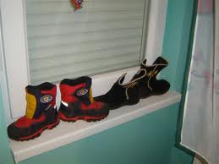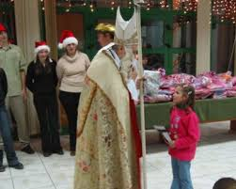

* **Christmas Wheat:** A beautiful custom of the feast on St. Lucy (December 13th) is to plant the “Christmas wheat.”

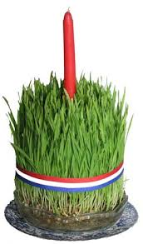

* **Christmas Eve:**At morning people starts to go to church to confess. The whole day is in the spirit of Christmas. That day people can’t eat meat so tradition is to prepare fish. The old tradition on that day is the burning of the yule log symbolizing light in the night that Christ was born which is almost forgotten nowadays and the decoration of a Christmas tree, a newer tradition At midnights start holly mass and many people go to church for Christmas celebration.

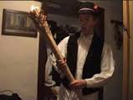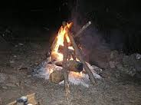

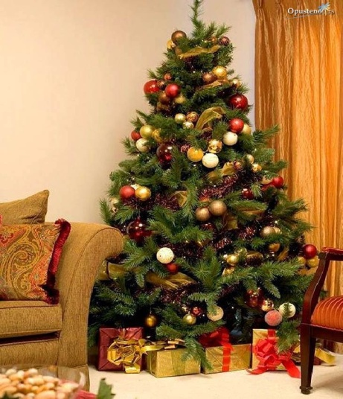

* **Christmas day:**The morning starts with opening presents which lies under the Christmas tree, Later people go to church on ceremonial mass.

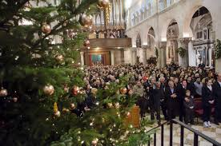

**Silvestre day:**There is no special tradition of that day, People prepare different dishes like roast pork, sarma (a mixture of chopped pork, chopped onion, rice and a bit of seasons, wrapped into a leaf of sauerkraut). In some parts of Croatian littoral it is pašticada with njoki (gnocchi with beef meat with sweet- acidic sauce with plum).

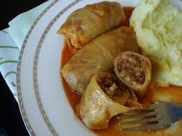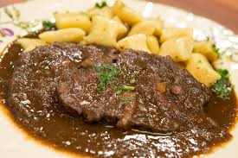

**EASTER CUSTOMS**

* **Procesije**-In many coastal towns of Dalmatia ceremonies and processions take place every night. throughout Holy Week

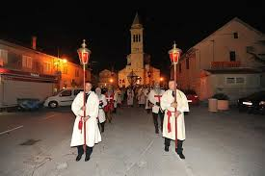

* **Krijes**- In central Croatia, villagers build huge bonfires

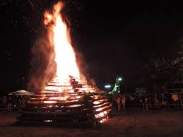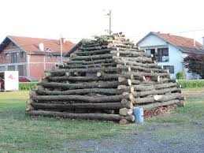

* **Holy Saturday**- People attend a late night mass at which the foods in their baskets are blessed and eaten for breakfast on Easter morning. Easter food is traditionally ham with radishes, spring onions and horseradish or roast lamb

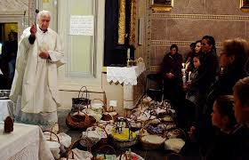

* **Pisanice**- The common custom in the whole Croatia is coloring and decorating of eggs. The most common color for eggs was red because of the abundance of red beets. In some areas the soot would be mixed with oak to make a dark brown color, and green plants would be used to make green dye. The most common phrase put on pisanice is Sretan Uskrs meaning Happy Easter

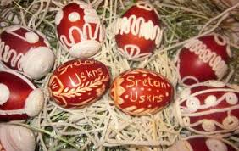

**FEAST OF THE ASSUMPTION OF MARY**

* The Croatian people have always worshipped the Blessed Virgin Mary. They have trusted in her heavenly intercession, honouring her in token of their gratitude as the Queen of the Croatian people. In honour of the Virgin Mary many processions take place in several places in Croatia. There are few famous Marian sanctuaries in Croatia where many pilgrims come to attend the Holly masses such as Sinj, Marija Bistrica, Trsat , Rijeka and Voćin.

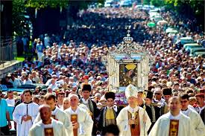

**ALL SAINTS' DAY**

* People in Croatia celebrate All Saints’ day attending the holy mass and visiting the cemeteries with the tradition of the lighting of candles and placing the flowers at the graves of theirs nearest ones who passed away.

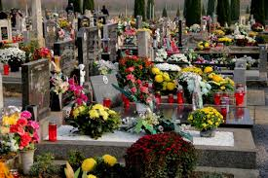

**EPIPHANY**

There are several traditions associated with The Feast of Three Kings in Croatia:

* **The blessing of water**

It was obligatory for a Croatian Christian family to have a container of blessed (holy) water in the home, which has been dedicated to blessing at the church or in front of the church on the eve of Epiphany.

* **Sprinkling with holy water**

The sprinkling of homes, livestock, barns, fields, vineyards with holy water occurred on the eve or on the very day of Epiphany. It was usual for the man of the house to sprinkle the livestock while the lady of the house sprinkled the garden, and outside the home etc.

* **starmen – songs**

A tradition associated with the Feast of Three Kings was in visiting of homes by “Starmen” (Zvjezdari) – three boys or men dressed as Kings, carrying a bright star in their hands and signing church hymns or other songs with which they invite the material and spiritual benefit for the household they visit.  Giving of gifts to the “Starmen” was associated with this tradition also.

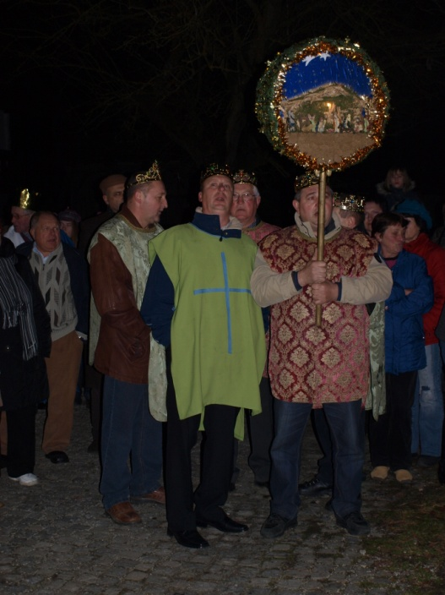

* **blessing of homes**

A priest, with his ministrants visits the home and bless it using a holy water sprinkler and placing a sign at the top of the door G + M + B (the first letters of the names of the Three Kings: Gaspar, Melchior and Balthasar)

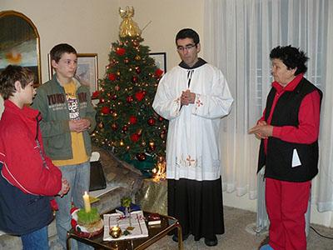

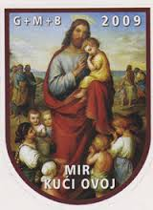

HOW DO WE CELEBRATE EASTER IN SPAIN

En nuestro colegio celebramos la Pascua con una Gymkhana de preguntas sobre las cosas que hemos dado de inglés y conocimiento del medio en todo el curso, encontrando unas tarjetas con las respuestas y dibujos aunque esto solo es para primaria. En infantil lo hacen buscando huevos de Pascua escondidos en el patio de infantil.

Los premios son huevos de chocolate para los vencedores es una bolsa llena de huevos de chocolate y un conejo delicioso. Esto es igual para infantil y primaria. Como también tenemos un profesor nativo, nos ayudaen las preguntas que no sabemos. Las respuestas pueden estar en cualquier sitio: en las flores, en las canastas de baloncesto, en los baños, en las puertas y… ¡Hasta en la parte externa de los contenedores de basura! Nuestra Gymkhana es muy loca.

In our school we celebrate Easter by doing a Gymkhana based on questions connected to Science contents that our students learn. They have to find the cards with pictures on them which are the answers to the previous questions and so on (only for primary level). The cards are located everywhere. The prize is a bag of chocolate eggs for the winners. The linguistic assistant usually helps the pupils. In Foundation States children have to look for little eggs cards, and the pupils who find more cards will be the winners.

<http://elalmendralmairena.blogspot.com.es/2015/04/actividad-de-final-de-trimestre-easter.html>

How do we celebrate Christmas. 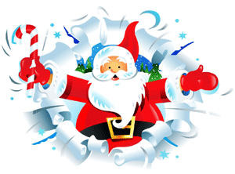

En nuestro colegio celebramos la Navidad. Decoramos la entrada con un Belén al que cada curso aporta figuras distintas, una vez recogidas las figuras las madres voluntarias nos ayudan a montarlo.

También hacemos postales de Navidad en inglés y en español en una cartulina con dibujos y decorados hechos por los alumnos.

Entre todos estas postales elegimos la mejor del colegio, esta postal será la que represente al colegio y será enviada a las familias.

Decoramos las clases con todas las postales hechas por los alumnos.

Algunos cursos preparan villancicos que cantan disfrazados de personajes navideños en el centro cívico de Mairena.

Aquí puedes ver dos videos de nuestro colegio en navidad:

In our school we celebrate Christmas. We decorate the hall with a big Belén in the main entrance. Pupils from different levels make some figure from the Belen and parents from the school help us to put the Belen and decorate it.

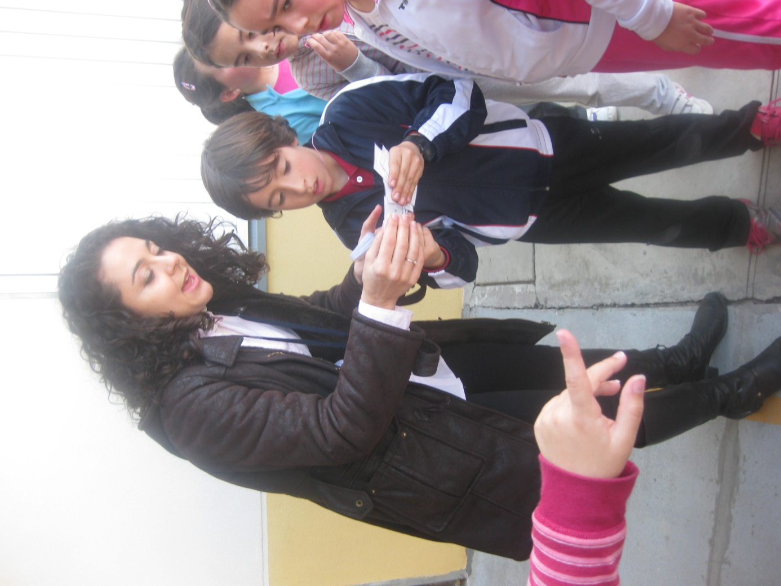

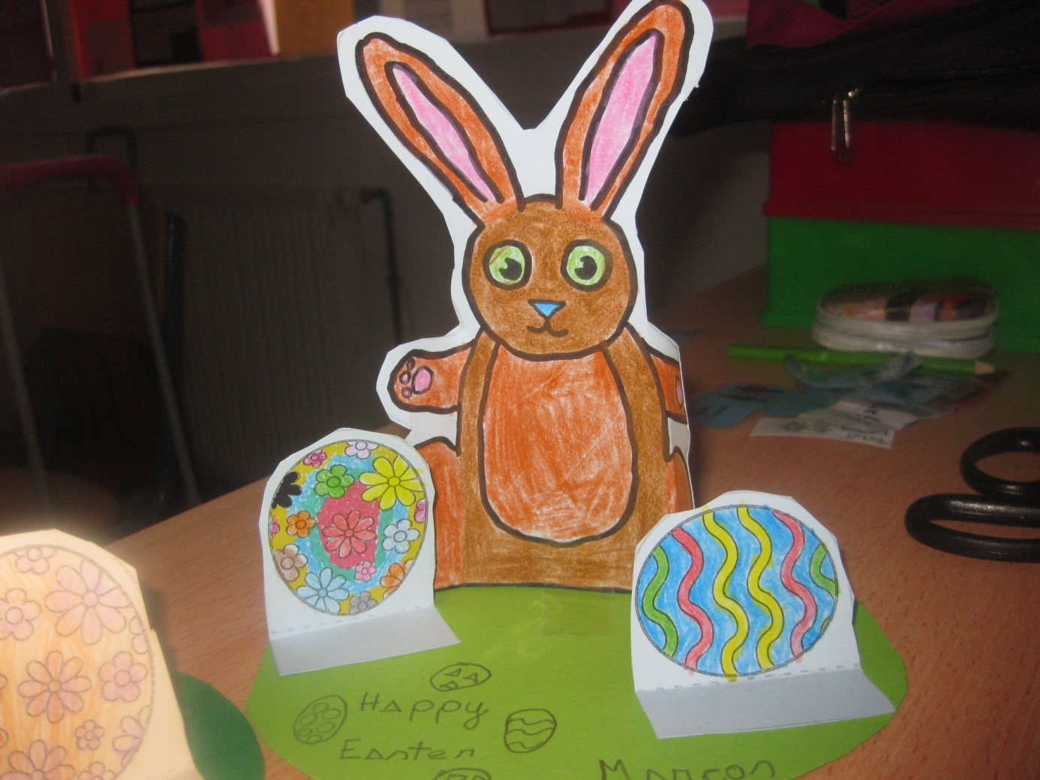

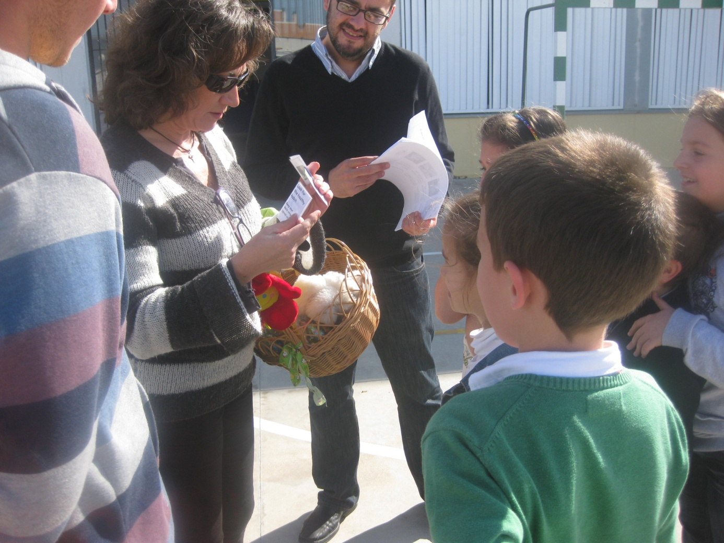

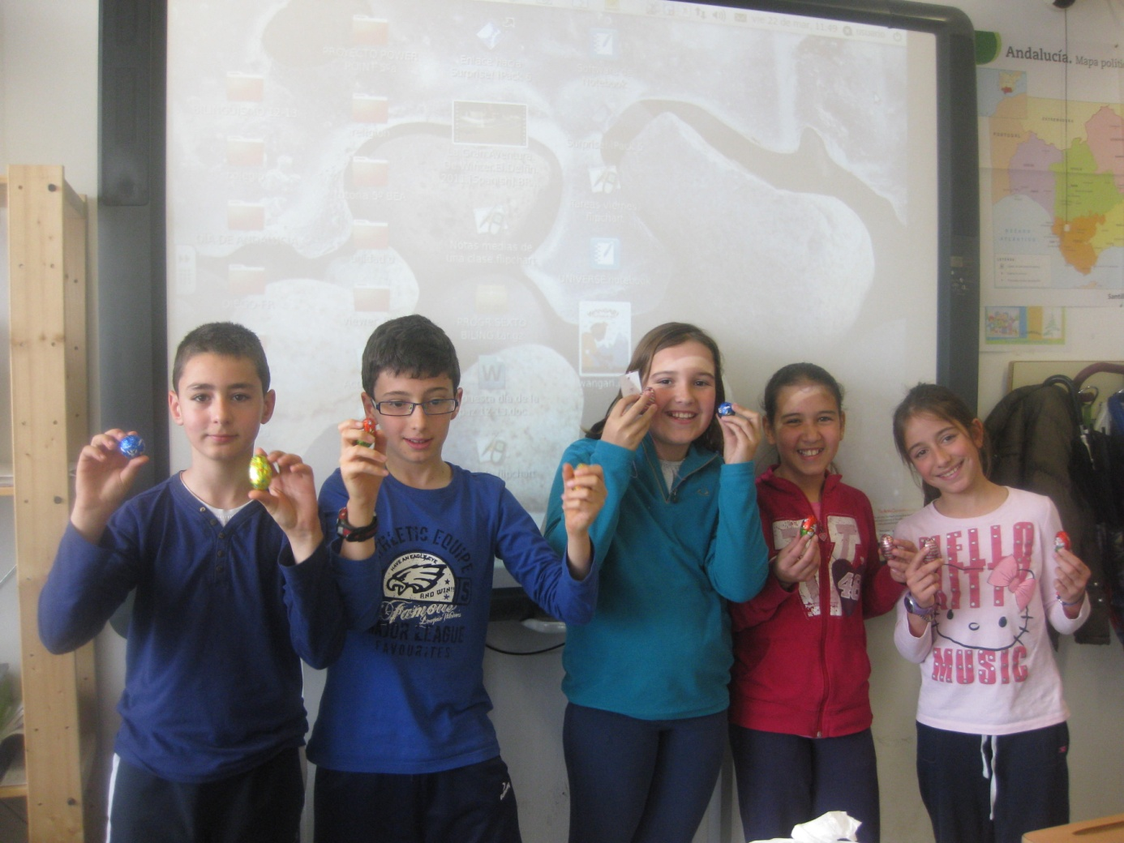

<http://ceipginer.blogspot.com.es/2014/12/nuestro-belen-solidario.html>  
<http://bilingualschoolginer.blogspot.com.es/2014/05/actuaciones-de-teatro-en-ingles.html>

Moreover, pupils make Christmas cards related with Christmas time and Christmas Eve. All the classrooms are decorated with them. Here are some videos and photos:

<https://www.youtube.com/watch?v=tVoYJ4L3VeE>

https://www.youtube.com/watch?v=6Duhz2pdhdY